م
MirasPro
Inheritance System
PROJECT MANUAL
Sharia-Compliant Digital Inheritance & Property Management
ASP.NET Core Blazor Server · Entity Framework Core · SQL Server
Version 1.0 · May 2026

📌 How to use this document
• Click any blue link in the Navigation Index to jump to a section.
• Use Word’s Table of Contents (next page) — right-click → Update Field.
• Diagrams are embedded as figures; zoom or print for clarity.
• Press Ctrl+F to search routes, tables, or Faraid terms.

Navigation Index
Interactive links below jump to major sections. Subsections appear in the auto-generated Table of Contents on the following page.
1. Introduction & Purpose
2. System Architecture & Technology Stack
3. Database Schema Overview
4. Authentication & Role-Based Access Control
5. User Guide — The User Portal
6. Admin Guide — The Admin Console
7. Core Algorithms — Faraid Calculator
8. Security & Compliance
9. Deployment & Configuration
10. Appendices

Table of Contents (Auto-Update)
In Microsoft Word: right-click the box below → Update Field → Update entire table.
Right-click here → Update Field to refresh Table of Contents

Version: 1.0
Product: MirasPro (Miras = inheritance; Pro = professional platform)
Stack: ASP.NET Core Blazor Server · C# · Entity Framework Core · SQL Server
Target framework: .NET 10.0
Document date: May 2026

1. Introduction & Purpose

1.1 Executive Summary
MirasPro is a secure, Sharia-aware digital platform for managing inheritance-related property records, legal heirs, Islamic share calculation (Faraid), family verification documents, and administrative dispute resolution. The system is implemented as a Blazor Server web application backed by SQL Server, with business logic encapsulated in scoped C# services and persistence handled through Entity Framework Core.
End users register real-world assets (residential, commercial, agricultural, and digital), attach heirs with Quranic/legal relationships, upload compliance documents (including the Family Registration Certificate), and run an automated Faraid engine that distributes estate value according to Hanafi-oriented rules—including Awl and Radd adjustments. Administrators operate a separate console to verify FRC submissions, review property documents and disputes, lock user profiles after verification, rotate security keys, and maintain a tamper-evident audit trail.

1.2 Societal Value & Problem Statement
In many jurisdictions—including Pakistan under frameworks such as the Muslim Family Laws Ordinance, 1961—inheritance disputes arise from:
- Informal or incomplete documentation of heirs and assets
- Manual, error-prone Faraid calculations when multiple fixed sharers coexist
- Lack of a single auditable record linking properties, heirs, and verified family status
MirasPro addresses these gaps by:
- 1. Centralizing property and heir data per owner
- 2. Enforcing a structured FRC verification gate before profiles are locked
- 3. Automating share computation with explicit flags when Awl or Radd applies
- 4. Providing administrators tools to approve, reject, and log every consequential action

1.3 Design Principles
Principle | Implementation in MirasPro
Separation of roles | Distinct login portals (/login/user, /login/admin), role checks in UserService and CurrentUserService
Server-side truth | Faraid, FRC, and compliance logic run in C# services—not client-only JavaScript
Least privilege for users after verification | User.IsEditable = false after FRC approval; users may add new records but not edit/delete existing ones
Auditability | AdminAuditLog records FRC approvals/rejections and other admin actions
Progressive compliance | ComplianceService surfaces missing FRC, pending review, or per-property documents

1.4 Scope & Limitations
In scope (as implemented):
- User and Administrator accounts with BCrypt password storage
- CRUD for properties and heirs (subject to IsEditable)
- Faraid calculation for a defined set of Quranic/Asabah relations (Hanafi-oriented rules in FaraidService)
- FRC upload and admin approve/reject with profile lock/unlock
- Property document upload (10 MB limit) and admin review via ComplianceService
- Dispute filing and admin status workflow (Pending, Under Review, Approved, Rejected)
Out of scope / disclaimers:
- The Faraid module is an educational/assistive tool, not a substitute for a qualified Islamic scholar or court order (see UI disclaimer on /faraid)
- Relations such as *Paternal Uncle* appear in the heir dropdown but are not computed by FaraidService unless mapped—they may show as excluded
- Transfers and AdminRegistrationInvites tables exist in the schema; transfer UI may be limited to property detail display
- No third-party identity provider (OAuth); authentication is email + password + session

2. System Architecture & Technology Stack

2.1 High-Level Architecture
┌─────────────────────────────────────────────────────────────────┐
│ Browser (User / Admin) │
└────────────────────────────┬────────────────────────────────────┘
│ SignalR (Blazor Server circuit)
▼
┌─────────────────────────────────────────────────────────────────┐
│ ASP.NET Core Host (Program.cs) │
│ ┌──────────────┐ ┌──────────────────────────────────────────┐ │
│ │ Razor Pages │ │ Scoped Services │ │
│ │ Components │──│ UserService, PropertyService, FaraidSvc, │ │
│ │ (.razor) │ │ FrcService, AdminService, ComplianceSvc │ │
│ └──────────────┘ └──────────────────┬───────────────────────┘ │
│ ┌──────────────┐ │ │
│ │ CurrentUser │ ProtectedSessionStorage (encrypted browser) │
│ │ Service │ │
│ └──────────────┘ ▼ │
│ ┌─────────────────────────┐ │
│ │ AppDbContext (EF Core) │ │
│ └────────────┬────────────┘ │
└─────────────────────────────────────┼────────────────────────────┘
│ TDS / SQL
▼
┌─────────────────────────┐
│ SQL Server (InheritanceDB)│
└─────────────────────────┘
│
┌─────────────┴─────────────┐
│ wwwroot/uploads/ │
│ documents/ frc_vault/ │
└───────────────────────────┘

2.2 Blazor Server Runtime Model
MirasPro uses Interactive Server render mode on authenticated pages (e.g. @rendermode @(new InteractiveServerRenderMode(prerender: false))). User events (button clicks, form posts, file uploads) are sent over a SignalR circuit to the server; UI updates are diffed back to the browser. Implications:
- Business logic and database access always execute on the server
- Session state for the logged-in user is held in CurrentUserService plus ProtectedSessionStorage
- File uploads stream to the server before being written under wwwroot/uploads/

2.3 Layered Application Structure
Layer | Location | Responsibility
Presentation | Components/Pages/, Components/Shared/ | Razor UI, navigation, forms
Application services | Services/*.cs | Transactions, validation, Faraid, FRC, disputes
Domain models | Models/*.cs | EF entities and annotations
Infrastructure | Data/AppDbContext.cs, Services/DatabaseSchemaInitializer.cs | EF Core mappings, schema patches
Scripts | Scripts/MirasPro_FullDatabase.sql | Full database bootstrap

Namespaces: UI/services often use inheritance_system; entities use InheritanceSystem.Models and InheritanceSystem.Data.

2.4 Service Registration & Dependency Injection
From Program.cs, all business services are registered scoped (one instance per Blazor circuit/request):
Service | Purpose
UserService | Registration, login, user deletion
CurrentUserService | Session keys, role flags, CanModifyRecords
PropertyService | Property CRUD and admin listing
HeirService | Heir CRUD grouped by property
FaraidService | Sharia share computation and apply-to-heirs
DisputeService | User disputes and admin review
DocumentService | Property document upload/list/delete
DashboardService | Aggregated stats via raw SQL
AdminService | Stats, lock/unlock, audit logging
FrcService | FRC submit, approve, reject
SecuritySettingsService | Admin access secret get/validate/update
ComplianceService | User compliance reports, admin document review

On startup, DatabaseSchemaInitializer.EnsureAsync runs to add missing columns/tables without dropping data.

2.5 Routing & Page Map
Route | Page | Audience
/ | Home | Public
/register | Register | Public
/login, /auth | Auth portal | Public
/login/user | User login | User
/login/admin | Admin login | Admin
/dashboard | Dashboard | User
/properties | Property list | User
/properties/{id} | Property detail | User
/heirs | Heir management + FRC upload | User
/frc | Dedicated FRC page | User
/faraid | Faraid calculator | User
/documents | Property documents | User
/disputes | Dispute applications | User
/admin/console | Admin dashboard | Admin
/admin/frc-queue | FRC review queue | Admin
/admin/frc-detail/{id} | Single FRC review | Admin
/admin/users | User management | Admin
/admin/properties | All properties | Admin
/admin/documents | Document review | Admin
/admin/disputes | Dispute review | Admin
/admin/compliance | Compliance matrix | Admin
/admin/security | Rotate admin secret | Admin

2.6 Use Case Diagram (User vs Administrator)
The diagram below summarizes primary actors and use cases as implemented in the codebase.
Figure 1: UML Diagram
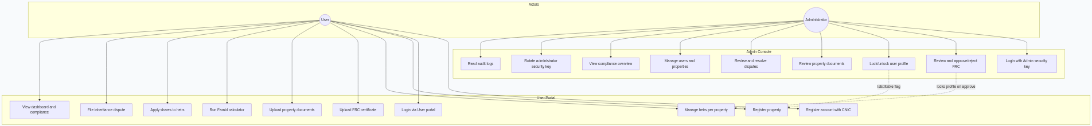
✓ Interactive diagram — refer to this figure when following related workflows in the text.

3. Database Schema Overview

3.1 Database Name & Provisioning
- Database: InheritanceDB
- Script: Scripts/MirasPro_FullDatabase.sql
- Connection string key: DefaultConnection in appsettings.json
The script creates all tables, indexes, and seeds SystemSettings.AdminAccessSecret with default value MirasPro@Admin2025 (overridable in Admin Security UI).

3.2 Entity Relationship Model
Figure 2: UML Diagram
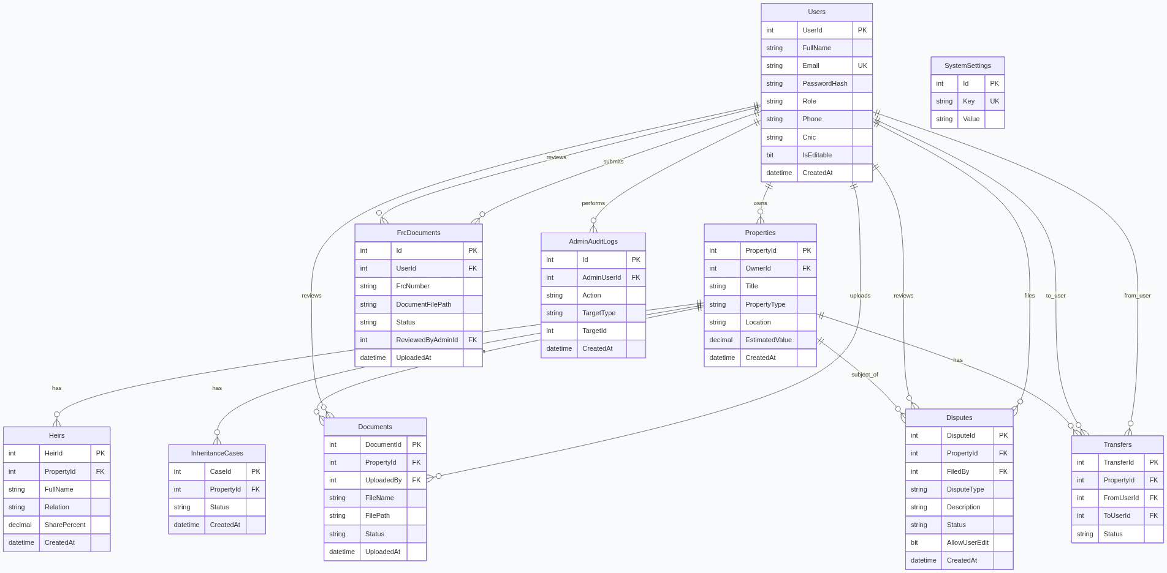
✓ Interactive diagram — refer to this figure when following related workflows in the text.

3.3 Table Reference
#### Users
Stores both User and Admin accounts. Distinguished by Role (User or Admin; legacy values Owner, LegalProfessional treated as user roles).
Column | Type | Notes
UserId | INT IDENTITY | Primary key
FullName | NVARCHAR(200) | Display name
Email | NVARCHAR(256) | Unique login
PasswordHash | NVARCHAR(500) | BCrypt hash
Role | NVARCHAR(50) | User / Admin
Phone, Cnic | Optional | CNIC required at user registration
BarCouncilNumber, FirmName | Optional | Reserved for legal professionals
IsEditable | BIT | 1 = user may edit/delete existing records; 0 = read-only for existing data
CreatedAt | DATETIME2 | UTC default in SQL script

#### Properties
Column | Notes
PropertyType | Residential, Commercial, Agricultural, Digital (UI filter options)
EstimatedValue | DECIMAL(18,2)—used by Faraid for PKR amount column
OwnerId | FK → Users, CASCADE delete

#### Heirs
One property may have many heirs. SharePercent is 0 until Faraid Apply to Heirs runs. Relation must match FaraidService keys exactly (e.g. Son's Son, not informal labels).
#### InheritanceCases
Linked to a property; Status typically Active or Closed. Exposed on property detail as CASE-{CaseId}.
#### Documents
Property-scoped files under wwwroot/uploads/documents/. Extended columns: Status (Pending/Approved/Rejected), AdminNotes, ReviewedByAdminId, ReviewedAt.
#### Disputes
Status | Meaning
Pending | Awaiting admin
Under Review | Admin investigating
Approved | Accepted
Rejected | Denied; may set AllowUserEdit for resubmission

#### FrcDocuments
User-level (not property-level) Family Registration Certificate vault under wwwroot/uploads/frc_vault/.
Status | Effect
Pending | Awaiting admin
Approved | AdminService.LockUserAsync → IsEditable = false
Rejected | UnlockUserAsync → user may resubmit

#### AdminAuditLogs
Records actions such as FRC_Approved, FRC_Rejected with TargetType, TargetId, and free-text Details.
#### SystemSettings
Key-value store; `AdminAccessSecret` gates admin registration and login.
#### Transfers
Records property transfer intent between users (FromUserId, ToUserId, TransferType, Status).
#### AdminRegistrationInvites
Optional invite-token table for legacy admin onboarding (unique SecureInviteToken).

3.4 Cascade Rules & Integrity
- Deleting a User cascades to their Properties, FrcDocuments, etc.
- Deleting a Property cascades to Heirs, Documents, Disputes, Cases
- FrcDocuments.ReviewedByAdminId uses ON DELETE NO ACTION in EF to avoid multiple cascade paths
Email uniqueness enforced by UQ_Users_Email.

3.5 Schema Migration on Startup
DatabaseSchemaInitializer compares the live database to expected columns (e.g. dispute review fields, document status) and applies ALTER TABLE / CREATE TABLE as needed. This allows teams to run the app against older databases without re-running the full drop script.

4. Authentication & Role-Based Access Control

4.1 Roles
Role constant | Value | Capabilities
AppConstants.RoleUser | User | User portal; cannot use admin login
AppConstants.RoleAdmin | Admin | Admin console; CanModifyRecords always true
Legacy | Owner, LegalProfessional | Treated as user via UserService.IsUserRole

4.2 Registration Workflows
User registration (/register → UserService.RegisterAsync):
- 1. User selects account type User
- 2. Provides first/last name, email, phone, CNIC (mandatory), password
- 3. Password hashed with BCrypt
- 4. Role forced to User, IsEditable = true
Administrator registration (UserService.RegisterAdminAsync):
- 1. User selects Administrator
- 2. Must supply valid Administrator security key (SecuritySettingsService.ValidateAdminSecretAsync)
- 3. Admin created with Role = Admin, IsEditable = false (admins are never locked by FRC flow)

4.3 Login Workflows
Portal | Route | Validation
User | /login/user | Email + password; rejects admin accounts
Admin | /login/admin | Email + password + admin security key

On success, CurrentUserService.SetUserAsync persists UserId, FullName, Email, Role to protected session storage.

4.4 Session Management
CurrentUserService keys (browser encrypted storage):
- miraspro_user_id
- miraspro_full_name
- miraspro_email
- miraspro_role
LogoutAsync clears all keys. Pages call LoadFromSessionAsync on init; unauthenticated users are redirected to login.

4.5 Record Editability (`IsEditable`)
Event | IsEditable
New user registration | true
FRC approved | false (via AdminService.LockUserAsync)
FRC rejected | true (via UnlockUserAsync for resubmission)

When IsEditable is false, CurrentUser.CanModifyRecords is false (non-admin). UI shows read-only banner on Properties and Heirs: users may still add new properties/heirs but cannot edit or delete existing rows.

5. User Guide — The User Portal

5.1 Getting Started
- 1. Open the site root / and choose Register or Login
- 2. Complete registration at /register (CNIC required for users)
- 3. Sign in at /login/user
- 4. Land on /dashboard
Recommended order: Properties → Heirs (+ FRC) → Documents → Faraid → Disputes (if needed).

5.2 Dashboard
Route: /dashboard
The dashboard (DashboardService) displays:
- Total properties, heirs, active inheritance cases
- Open disputes (Pending / Under Review)
- Pending transfers
- Document count and total estimated estate value (PKR)
- Quick links to Properties, Heirs, Faraid, Documents, Disputes

5.3 Property Management
Route: /properties, detail at /properties/{id}
Register property:
- 1. Click Register Property
- 2. Enter title, type, location, estimated value
- 3. PropertyService.CreateAsync validates title and associates OwnerId
Property types (dropdown):
- Residential
- Commercial
- Agricultural
- Digital
List features: search by title/location, filter by type, view heir count and case status.
Property detail shows heirs, inheritance cases, transfers, and linked documents for one property.

5.4 Heir Management
Route: /heirs
Add heir:
- 1. Click Add Heir
- 2. Select property, full name, and Relation from structured dropdown (Spouse, Parents, Children, Siblings, Other)
- 3. Share percent is saved as 0 on create—the Faraid page computes shares
- 4. HeirService prevents manual shares from pushing total above 100% if manually set
Relation groups in UI (must match Faraid engine spelling):
- Spouse: Husband, Wife
- Parents: Father, Mother, Paternal Grandfather, Maternal Grandmother, Paternal Grandmother
- Children: Son, Daughter, Son's Son, Son's Daughter
- Siblings: Full / Paternal Half / Maternal Half Brother and Sister
- Other: Paternal Uncle, Paternal Uncle's Son (not computed by Faraid—may appear excluded)
Grouped view: heirs appear under each property card with aggregate share pill (pending if 0%, complete near 100%).

5.5 Family Registration Certificate (FRC)
Routes: /heirs (embedded form), /frc (dedicated page)
Submit FRC:
- 1. Enter FRC Number (e.g. B-42201-0123456)
- 2. Attach file: PDF, JPG, JPEG, or PNG, max 10 MB
- 3. FrcService.SubmitAsync stores file in wwwroot/uploads/frc_vault/ and inserts row with Status = Pending
Resubmission: allowed when latest FRC is Rejected or no prior submission exists; not allowed while Pending or after Approved.
After approval: profile locked—see Section 4.5.

5.6 Document Management
Route: /documents
- 1. Select property
- 2. Upload file (max 10 MB) via DocumentService.UploadAsync
- 3. Files stored at wwwroot/uploads/documents/{guid}_{originalName}
- 4. Admin may later approve/reject via compliance/document admin pages
ComplianceService warns if any property lacks uploaded documents.

5.7 Faraid Calculator (User Flow)
Route: /faraid
- 1. Select a property from dropdown
- 2. On change, page calls FaraidService.ComputeAsync(propertyId, userId)
- 3. Review table: heir name, relation, fraction label, percent, PKR amount, excluded reasons
- 4. Badges show Awl Applied, Radd Applied, total percent
- 5. Click Apply to Heirs → ApplyToHeirsAsync writes SharePercent to database
If no heirs exist, the result includes a note directing the user to Heir Management first.

5.8 Dispute Management
Route: /disputes
File dispute:
- 1. Choose property, dispute type, description
- 2. Status set to Pending, FiledBy = current user
Edit after rejection: only if admin set AllowUserEdit and status is Rejected or Pending per DisputeService.UpdateByUserAsync.

5.9 Compliance Indicators
On /heirs, ComplianceService.GetUserComplianceAsync may show banners:
Code | Severity | Message pattern
FRC_MISSING | error | No FRC uploaded
FRC_PENDING | warning | Awaiting admin
FRC_REJECTED | error | Resubmit corrected FRC
NO_PROPERTY | warning | Register a property
DOC_{propertyId} | warning | Specific property missing documents

6. Admin Guide — The Admin Console

6.1 Administrator Access
- 1. Navigate to /login/admin
- 2. Enter email, password, and Administrator security key
- Default (seeded): MirasPro@Admin2025
- Stored in SystemSettings key AdminAccessSecret
- 3. Successful login sets session with Role = Admin
Administrators can also be registered at /register by selecting Administrator and supplying the same key.

6.2 Admin Console Dashboard
Route: /admin/console
Displays aggregate metrics via AdminService:
- Total users (including legacy roles)
- Total properties
- Active disputes count
- FRC queue summary
- Recent AdminAuditLog entries
Sidebar links to FRC queue, users, properties, documents, disputes, compliance, and security.

6.3 FRC Verification Workflow
Routes: /admin/frc-queue, /admin/frc-detail/{id}
- 1. Filter submissions: All, Pending, Approved, Rejected
- 2. Open document link (DocumentFilePath under /uploads/frc_vault/)
- 3. Approve: optional notes → status Approved, user locked, audit FRC_Approved
- 4. Reject: rejection notes required → status Rejected, user unlocked, audit FRC_Rejected

6.4 Activity Diagram — FRC Upload & Admin Verification
Figure 3: UML Diagram
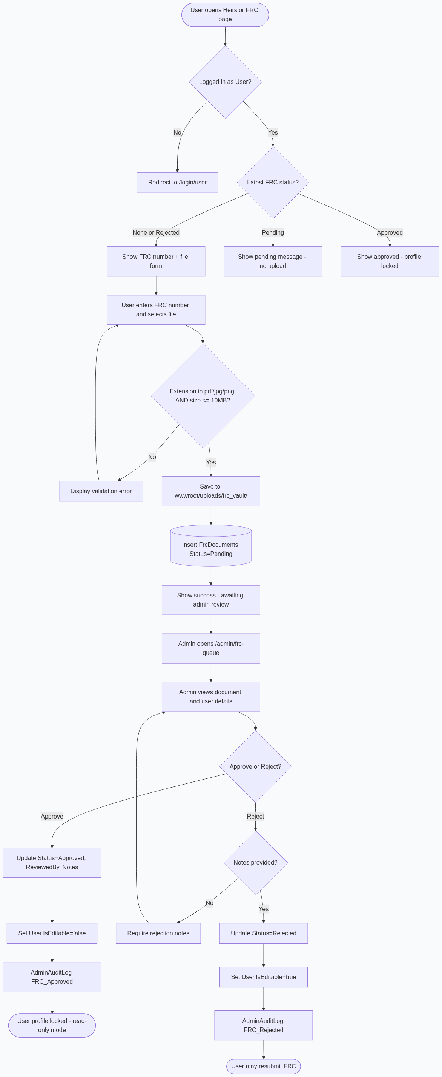
✓ Interactive diagram — refer to this figure when following related workflows in the text.

6.5 User Management
Route: /admin/users
- List all users
- Delete user (cannot delete self) via UserService.DeleteAsync
- Observe IsEditable / role

6.6 Property & Document Oversight
Route | Function
/admin/properties | View/delete any user's property
/admin/documents | Approve/reject/delete property documents
/admin/compliance | Matrix of users with missing FRC/docs

6.7 Dispute Review
Route: /admin/disputes
Admin sets status to Pending, Under Review, Approved, or Rejected. Rejection requires AdminRejectionReason. Optional Allow user edit flag enables resubmission.

6.8 Compliance Overview
/admin/compliance loads GetAllUsersComplianceAsync—sorted with incomplete profiles first.

6.9 Security Settings & Audit Logs
Route: /admin/security
- Change admin secret: minimum 8 characters, must confirm current key
- Updates SystemSettings with UpdatedByAdminId
Audit logs visible on console; entries include FRC actions, document actions, user deletion, etc.

7. Core Algorithms — Faraid Calculator

7.1 Islamic Inheritance Concepts
MirasPro implements a fixed-share (Fard) and residuary (Asabah) model aligned with common Hanafi teaching, as noted on the Faraid page (Muslim Family Laws Ordinance, 1961 reference in UI).
Term | Meaning in system
Fard | Quranic fixed fractions (½, ¼, ⅛, ⅙, ⅓, etc.) stored in shareMap
Asabah | Residuary heirs listed in residuaries; share residue after fixed shares
Hajb | Implemented as excluded dictionary with human-readable reasons
Awl | When sum of fixed shares > 1, all fixed shares scaled by 1/fixedSum
Radd | When residue remains but no residuary, surplus redistributed among fard heirs (spouse excluded)

7.2 Supported Heir Relations
Relations counted in FaraidService.ComputeAsync (exact string match):
Category | Relations
Spouse | Husband, Wife
Ascendants | Father, Mother, Paternal Grandfather, Paternal Grandmother, Maternal Grandmother
Descendants | Son, Daughter, Son's Son, Son's Daughter
Siblings | Full Brother/Sister, Paternal Half Brother/Sister, Maternal Half Brother/Sister

Examples of fixed rules encoded:
- Husband: ½ without descendants, ¼ with descendants
- Wife: ¼ without descendants, ⅛ with descendants
- Single daughter: ½; multiple daughters: ⅔
- Mother: ⅓ or ⅙ depending on descendants/siblings
- Father: ⅙ + residue or full residuary depending on descendants
Sons (and similar male residuaries) take residue with 2:1 male-female ratio when sharing with daughters.

7.3 Computation Pipeline
- 1. Load property and heirs for propertyId + ownerId
- 2. Group heirs by Relation and count each category
- 3. Compute flags: hasMaleDescendant, hasAnyDescendant, hasFatherOrPGF, siblingsCount
- 4. Build shareMap (fixed), residuaries, excluded
- 5. Sum fixed shares; apply Awl if sum > 1
- 6. Compute residue = 1 - fixedSum; distribute to residuaries or apply Radd
- 7. Map group fractions to individual heirs (divide by count in group)
- 8. Set Amount = (Percent/100) * EstimatedValue
Return type: FaraidResult with Shares, Notes, AwlApplied, RaddApplied, TotalPercent.

7.4 Awl (Increase of Denominator)
When fixedSum > 1m:
decimal factor = 1m / fixedSum;
// Each fixed share multiplied by factor; label suffixed with "(Awl)"
result.AwlApplied = true and a note is added to Notes.

7.5 Radd (Return of Surplus)
When residue > 0, no residuary heirs, but fixed heirs exist:
- Spouse keys (Husband, Wife) excluded from redistribution
- Remaining fard heirs receive additional share proportional to their fixed fractions
- Labels suffixed with (Radd)

7.6 Applying Shares to the Database
ApplyToHeirsAsync:
- 1. Re-runs ComputeAsync
- 2. For each FaraidShare, updates matching Heir.SharePercent (rounded to 4 decimals)
- 3. SaveChangesAsync
User should add all heirs with correct relations before applying.

7.7 Sequence Diagram — Faraid Calculation
Figure 4: UML Diagram
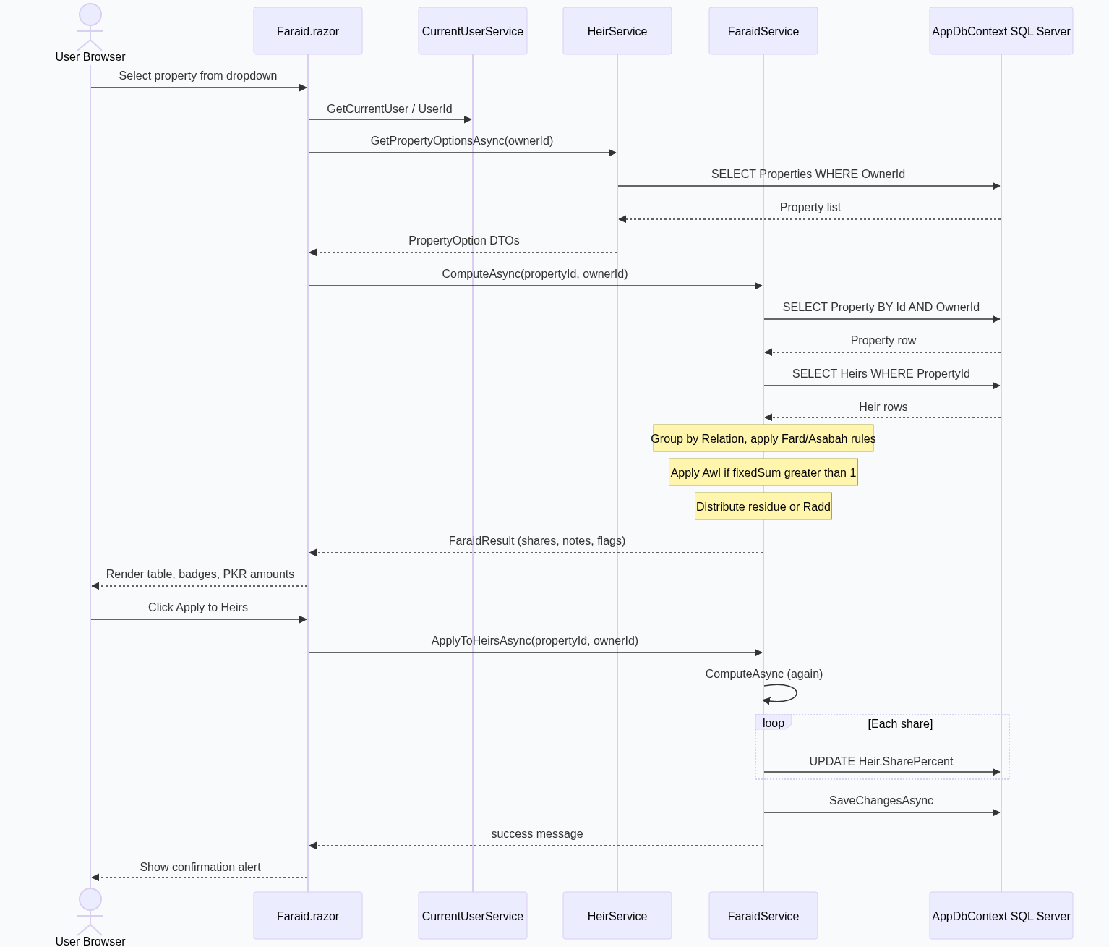
✓ Interactive diagram — refer to this figure when following related workflows in the text.

8. Security & Compliance

8.1 Password Hashing
Passwords are never stored in plain text. BCrypt.Net.BCrypt.HashPassword on registration; BCrypt.Verify on login.

8.2 Protected Session Storage
Microsoft.AspNetCore.Components.Server.ProtectedBrowserStorage.ProtectedSessionStorage encrypts session payload in the browser. Keys are prefixed miraspro_*. Survives refresh within the same browser session; cleared on logout.
Note: This is not ASP.NET Core Identity cookie authentication—it is custom session state suitable for Blazor Server prototypes. Production hardening may add HTTPS-only cookies, idle timeout, and server-side session validation.

8.3 Administrator Security Key
Aspect | Detail
Storage | SystemSettings row AdminAccessSecret
Default | MirasPro@Admin2025 (AppConstants.DefaultAdminAccessSecret)
Used at | Admin registration, admin login, secret rotation
Rotation | /admin/security — requires current key, min length 8

8.4 File Upload Validation
Upload type | Extensions | Max size | Storage path
FRC | .pdf, .jpg, .jpeg, .png | 10 MB | /uploads/frc_vault/
Property documents | Browser file (service checks size) | 10 MB | /uploads/documents/

Filenames sanitized with timestamp/GUID prefixes to reduce collision and path traversal risk.

8.5 Authorization Patterns in the UI
- Pages check CurrentUser.IsLoggedIn and role before loading data
- Services enforce ownership: properties/heirs/disputes filtered by OwnerId
- Admin routes use AdminLayout and admin role checks
- CanModifyRecords gates edit/delete buttons in Razor markup

9. Deployment & Configuration

9.1 Prerequisites
- .NET 10 SDK (project targets net10.0)
- SQL Server (LocalDB, Express, or full instance)
- SQL Server Management Studio (optional, for scripts)
- Windows/macOS/Linux dev environment for dotnet run

9.2 Database Setup
Option A — Full script (recommended for new environments):
- 1. Open Scripts/MirasPro_FullDatabase.sql in SSMS
- 2. Adjust @DropExisting at top: use 1 only to wipe all data
- 3. Execute script — creates InheritanceDB and tables
- 4. Default admin secret seeded automatically
Option B — App startup:
Run the application once; DatabaseSchemaInitializer patches missing objects.
See also Scripts/README.md for seed admin account script MirasPro_SeedData.sql.

9.3 Connection String Configuration
Edit appsettings.json:
{
"ConnectionStrings": {
"DefaultConnection": "Server=YOUR_SERVER;Database=InheritanceDB;Trusted_Connection=True;TrustServerCertificate=True;Connect Timeout=15;"
}
}
Replace YOUR_SERVER with your instance name (example in repo: NUMAN315\MSSQLSERVER01). For SQL authentication, use User Id=...;Password=... instead of Trusted_Connection.
appsettings.Development.json may override logging; connection string typically remains in base appsettings.json.

9.4 Running the Application
cd "inheritance system"
dotnet restore
dotnet run
Note the HTTPS/HTTP URLs in console output (e.g. https://localhost:7xxx). Browse to / for marketing home, /register to create accounts.
First-time checklist:
- 1. Database exists and connection string is valid
- 2. Register a user account
- 3. Register an admin (with security key) or run seed script
- 4. Upload test FRC and verify admin queue

9.5 Upload Directories
Ensure write permissions exist (created automatically on first upload):
- wwwroot/uploads/documents/
- wwwroot/uploads/frc_vault/
The .csproj includes a folder placeholder for frc_vault.

9.6 Optional Seed Data
Item | Value
Seed admin email | admin@miraspro.pk (if using seed script)
Seed password | Admin@123 (change in production)
Admin key | MirasPro@Admin2025

Generate password hash:
dotnet run --project Scripts/HashPassword/HashPassword.csproj -- "YourPassword"

10. Appendices

10.1 Project Folder Structure
inheritance system/
├── Components/
│ ├── Pages/ # User + Admin Razor pages
│ ├── Shared/ # AdminSidebar, layouts
│ └── Routes.razor
├── Data/
│ └── AppDbContext.cs
├── Models/ # EF entities
├── Services/ # Business logic
├── Scripts/ # SQL + HashPassword utility
├── wwwroot/
│ ├── css/ # miras-theme, page styles
│ └── uploads/ # Runtime file storage
├── Program.cs
├── appsettings.json
└── inheritance system.csproj

10.2 NuGet Dependencies
Package | Version | Role
BCrypt.Net-Next | 4.2.0 | Password hashing
Microsoft.EntityFrameworkCore | 10.0.8 | ORM
Microsoft.EntityFrameworkCore.SqlServer | 10.0.8 | SQL Server provider
Microsoft.EntityFrameworkCore.Design / Tools | 10.0.8 | Migrations tooling

10.3 Legal Disclaimer
The Faraid Calculator page displays an explicit disclaimer: results follow standard Hanafi-oriented rules for education and planning; complex cases (*Mushtarakah*, *Akdariyah*, non-Muslim heirs, etc.) require qualified scholarly or legal advice. MirasPro does not issue legally binding fatwas or court judgments.
End of MirasPro Project Manual
*This document reflects the implementation in the MirasPro inheritance system repository as of the manual version date. For schema changes after deployment, consult DatabaseSchemaInitializer.cs and Scripts/UpdateSchema.sql.*

— End of MirasPro Project Manual —

